This Document Applies Users Who Modify Wireless Name And Password
Applicable Model：Tenda F9 Question Category：Wireless Configuration

Computer connect to wireless router with Ethernet cable, if you use laptop, you also can connect to wireless router via Wi-Fi, the steps as below:
Wire Connection:
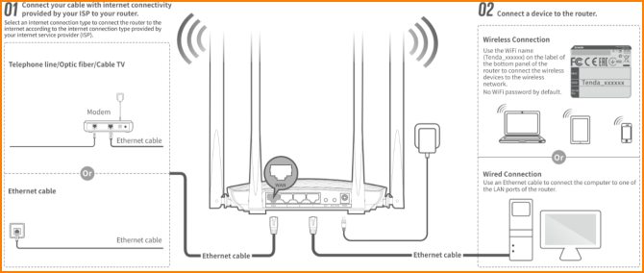
Wireless Connection:
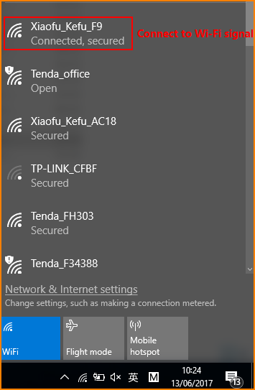
Open browser, input “tendawifi.com” or “192.168.0.1”in address bar and then you will login the management webpage of router. (default login username and password are both “admin”);
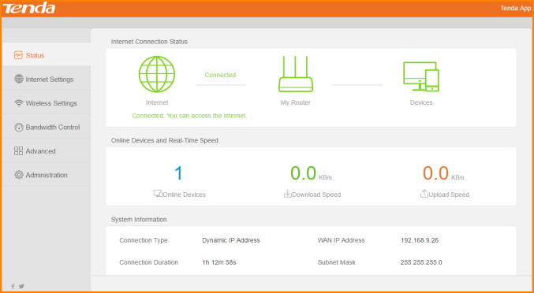
1. Click “Wireless Settings”, and you will find “Wi-Fi Name and Password”. You can modify them as you want and click OK.
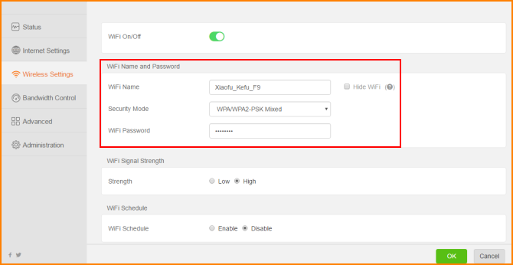
Noted: If you connect router via wireless. After modifying wireless name and password, please connect Wi-Fi signal again.

